

INTERNSHIP REPORT

2024

**SHAIK NAJEER SULTHAN 23F05A505**

**St. Ann’s College of Engineering And Technology Computer Science and Engineering**

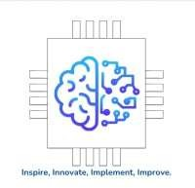

**SUBMITTING TO:**

**SAI SATISH SIR**

**ARTIFICIAL INTELLIGENCE MEDICAL AND ENGINEERING RESEARCHERS SOCIETY**

**INFO @AimerSociety.com**

AN INTERNSHIP REPORT

ON

**ARITIFICIAL INTELLIGENCE MEDICAL ENGINEERIG RESEARCH SOCIETY**

A report submitted in part fulfilment of B.Tech in Computer Science and Engineering

By

**SHAIK NAJEER SULTHAN (23F05A0505)**

Under the Supervision of

**Mr. N. Lakshmi Narayana**

**Associate Profissor**



**ST.ANN'S COLLEGE OF ENGINEERING AND TECHNOLOGY**

**An Autonomous Institution**

Approved by AICTE& Permanently Affiliated to JNTUK, Kakinada Accredited by NAAC with “A” Grade and NBA

Nayunipalli village, ChallaReddy Palem Post,Vetapalem Mandal, Chirala. [www.sacet.ac.in](http://www.sacet.ac.in/)

#### ST.ANN'S COLLEGE OF ENGINEERING & TECHNOLOGY

Department of Computer Science & Engineering CHIRALA-523187



**CERTIFICATE**

This is to certify that the short term internship Project Report entitled " **ARITIFICIAL INTELLIGENCE MEDICAL ENGINEERIG RESEARCH SOCIETY**" submitted by **SHAIK NAJEER SULTHAN** of B. Tech (Computer Science and Engineering) in the Dept of Computer Science and Engineering of St. Ann's College of Engineering & Technology as a partial fulfilment of the requirements for the Course work of **B. Tech** in Computer Science and Engineering is a record of Short term internship Project carried out under my guidance and supervision in the Academic year **2024.**

Date:

**Signature of the Supervisor Signature of the Head of the Department**

**Mr. N. Lakshmi Narayana Dr. P. Harini**

**Designation: Assoc. Profissor Designation: HOD**

**Department: CSE Department: CSE**

Signature of the Examiner-1 Signature of the Examiner-2

Page **4** of **62**

**PROGRAM BOOK FOR**

SHORT-TERM INTERNSHIP

# (Virtual)

**Name of the Student: SHAIK NAJEER SULTHAN**

**Name of the College:** St. Ann’s College Of Engineering &Technology

**Registration Number:**23F05A0505

**Period of Internship: 2 Months From:** 31-05-2024 **To** 19-07-2024

**Name & Address of the Intern organization:** AIMERS

**JNTU KAKINADA UNIVERSITY**

YEAR:2024

# An Internship Report on

“**ARITIFICIAL INTELLIGENCE MEDICAL ENGINEERIG RESEARCH SOCIETY**”

*Submitted in accordance with the requirement for the degree of*

B.Tech

*Under the Faculty Guide of*

N. Lakshmi Narayana

*Department of*

COMPUTER SCIENCE AND ENGINEERING

**Submitted by:**

SHAIK NAJEER SULTHAN

**Reg. No:** 23F05A0505

*Department of*

COMPUTER SCIENCE AND ENGINEERING

(ST.ANN’S COLLEGE OF ENGINEERING & TECHNOLOGY)

# Student’s Declaration

I, **SHAIK NAJEER SULTHAN** a student of **B.Tech** Program, Reg. No. **23F05A0505** of the Department of **Computer Science and Engineering** College do hereby declare that I have completed the mandatory internship from **31-05- 2024 to 18-07-2024** in **AIMERS** under the Faculty Guideship **of N. Lakshmi Narayana**, Department of **Computer Science and Engineering** in **St. Ann’s College Of Engineering & Technology, chirala .**

(SHAIK NAJEER SULTHAN) 23F05A0505

## Official Certification

This is to certify that **SHAIK NAJEER SULTHAN** Reg. No. **23F05A0505** has completed his/her Internship in **MAKE SKILLED** on **ARITIFICIAL INTELLIGENCE MEDICAL ENGINEERIG RESEARCH SOCIETY** under my supervision as a part of partial fulfillment of the requirement for the Degree of **Bachelor Of Technology** in the **Department of** **Computer science and Engineering** **in St. Ann’s College Of Engineering & Technology, Chirala** *.*

This is accepted for evaluation.

**(Signatory with Date and Seal)**

**Endorsements**

**Faculty Guide**

**Head of the Department**

## Certificate from Intern Organization:

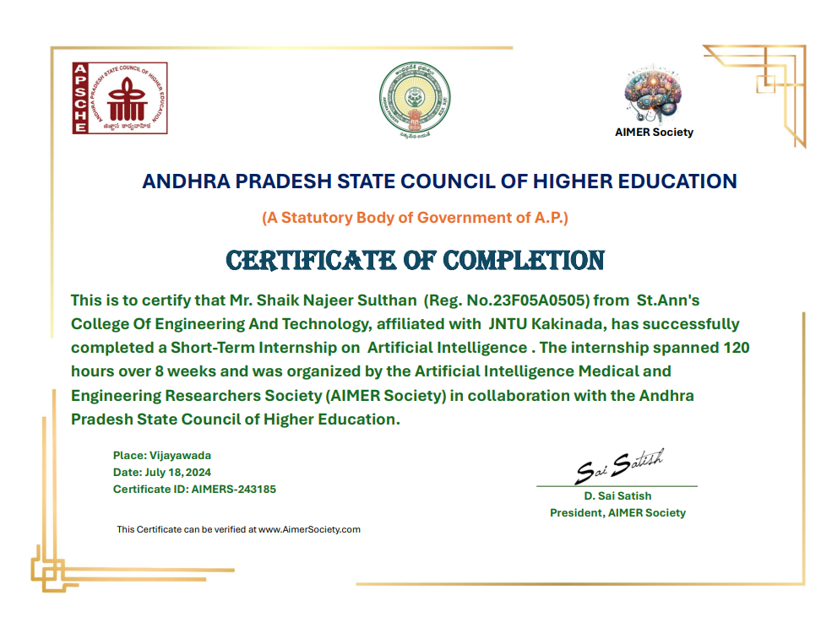

**Acknowledgements**

On this great occasion of accomplishment of summer internship on **ARITIFICIAL INTELLIGENCE MEDICAL ENGINEERIG RESEARCH SOCIETY**, we would like to sincerely express gratitude to our guide **Mr. N. Lakshmi Narayana** been supported through the completion of this Internship.

I would also be thankful to our Head of the Department **Dr. P. Harini** of St. Ann’s College of Engineering & Technology for providing valuable suggestions in completion of this Internship.

I would also be thankful to the Principal, **Dr. K. JAGADESH BABU** and Management of St. Ann’s College of Engineering & Technology for providing all the required facilities in completion of this Internship.

I would like to extend my deep appreciation to **AIMERS**, without their support and coordination we would not have been able to complete this Internship.

Finally, as one of the team members, I would like to appreciate all my group members for their support and coordination, I hope we will achieve more in our future endeavors.

**SHAIK NAJEER SULTHAN 23F05A0505**

**ABOUT AIMERS**

**Details about AIMER Society**

**Name:** Artificial Intelligence Medical and Engineering Researchers Society (AIMER Society)

**Overview:**

The Artificial Intelligence Medical and Engineering Researchers Society (AIMER Society) stands as a premier professional organization at the forefront of the advancement of Artificial

Intelligence (AI) within the realms of medical and engineering research. This esteemed society is committed to driving innovation and excellence in AI by fostering a collaborative environment among researchers, practitioners, and students from diverse backgrounds and disciplines.

The AIMER Society's mission is to serve as a catalyst for the development and application of

cutting-edge AI technologies that can address complex challenges in healthcare and engineering. By creating a vibrant and inclusive platform, the society facilitates the exchange of knowledge,

ideas, and best practices among its members. This collaborative approach ensures that AI

research is not only innovative but also practically applicable, leading to real-world solutions that can significantly improve medical outcomes and engineering processes.

In pursuit of its mission, the AIMER Society organizes a wide array of activities and initiatives designed to promote AI research and development. These include annual conferences,

symposiums, and workshops that bring together leading AI experts to discuss the latest advancements and trends. Such events provide invaluable opportunities for networking, collaboration, and professional growth.

**Mission**:

The mission of the AIMER Society is to promote the development and application of AI

technologies to solve complex medical and engineering problems, improve healthcare outcomes, and enhance engineering solutions. The society aims to bridge the gap between theoretical

research and practical implementation, encouraging interdisciplinary collaboration and real- world impact.

**Objectives**:

* To advance research in AI and its applications in medical and engineering fields.
* To provide a platform for researchers, practitioners, and students to share knowledge and collaborate on AI projects.
* To organize conferences, workshops, and seminars for the dissemination of AI research and knowledge.
* To support the professional development of AI researchers and practitioners through training programs, certifications, and networking opportunities.
* To foster ethical AI practices and address societal challenges related to AI deployment.

**Key Activities:**

* + Conferences and Workshops: Organizing annual conferences, symposiums, and workshops that bring together leading AI experts, researchers, and practitioners to discuss the latest advancements and trends in AI.
  + Research Publications: Publishing high-quality research papers, journals, and articles on AI technologies and their applications in medical and engineering fields.
  + Competitions and Contests: Hosting AI model development and chatbot contests to encourage innovation and practical applications of AI among students and

professionals.

* + Training Programs: Offering training and certification programs in AI and related technologies to enhance the skills and knowledge of members.
  + Collaboration Projects: Facilitating collaborative projects between academia, industry, and healthcare institutions to drive AI innovation and practical solutions.

**Membership**:

* + - The AIMER Society offers various membership categories, including individual, student, and corporate memberships. Members gain access to exclusive resources, networking opportunities, and discounts on events and publications. The society encourages participation from AI enthusiasts, researchers, practitioners, and

organizations interested in the advancement of AI technologies.

**Leadership**:

* The AIMER Society is led by a team of experienced professionals and experts in the

fields of AI, medical research, and engineering. The leadership team is responsible for strategic planning, organizing events, and guiding the society towards achieving its

mission and objectives.

**Impact and Achievements:**

* Developed AI models for early diagnosis and treatment of medical conditions.
* Contributed to significant advancements in engineering solutions through AI technologies.
* Fostered a global community of AI researchers and practitioners.
* Organized successful conferences and workshops with high participation and impactful outcomes.
* Published influential research papers and articles in reputed journals.

**Future Goals:**

* Expand the scope of research and applications in AI to cover emerging fields and technologies.
* Increase collaboration with international AI societies and organizations.
* Enhance training and certification programs to meet the evolving needs of AI professionals.
* Promote ethical AI practices and address challenges related to AI governance and societal impact.

**Contact Information:**

* Website: AIMER Society Website [http://www.aimersociety.com](http://www.aimersociety.com/)
* Email: [info@aimersociety.org](mailto:info@aimersociety.org)
* Phone: +91 9618222220
* Address: Sriram Chandranagar, Vijayawada

**INTERNSHIP REPORT CONTENT**

**List of Topics Learned:**

|  |  |
| --- | --- |
| **S.no** | **List of Topics** |
| **1.** | Computer Vision |
| **2.** | Convolutional Neural Networks (CNN) |
| **3.** | Image Classification |
| **4.** | Image Object Detection |
| **5.** | YOLO (You Only Look Once) - Object Detection |
| **6.** | Medical Image Analysis and Labelling |
| **7.** | Human Pose Estimation: |
| **8.** | Mediapipe Studio |
| **9.** | OpenCV Basics |
| **10.** | Chatbot Development |
| **11.** | Google Dialogflow |
| **12.** | Generative AI, AI Models |
| **13.** | Visual Question & Answering |
| **14.** | Document Question & Answering |
| **15.** | Table Question & Answering |
| **16.** | Large Language Models (LLMs) |
| **17.** | Other Topics |

**TASKS:**

|  |  |  |
| --- | --- | --- |
| **S.no** | **TITTLE** | **LINKS** |
| **1.** | **Power BI:**  Using power bi we can visualize the data in different ways for  example in bar charts, pie charts, etc… | [**https://www.linkedin.com/posts/shaik**](https://www.linkedin.com/posts/shaik-najeer-sulthan-09633a311_indianserver-aimers-aimersociety-activity-7210606240161275905-cjNq?utm_source=share&utm_medium=member_desktop)  [**-najeer-sulthan-**](https://www.linkedin.com/posts/shaik-najeer-sulthan-09633a311_indianserver-aimers-aimersociety-activity-7210606240161275905-cjNq?utm_source=share&utm_medium=member_desktop)[**09633a311_indianserver-aimers-**](https://www.linkedin.com/posts/shaik-najeer-sulthan-09633a311_indianserver-aimers-aimersociety-activity-7210606240161275905-cjNq?utm_source=share&utm_medium=member_desktop)[**aimersociety-activity-**](https://www.linkedin.com/posts/shaik-najeer-sulthan-09633a311_indianserver-aimers-aimersociety-activity-7210606240161275905-cjNq?utm_source=share&utm_medium=member_desktop)[**7210606240161275905-**](https://www.linkedin.com/posts/shaik-najeer-sulthan-09633a311_indianserver-aimers-aimersociety-activity-7210606240161275905-cjNq?utm_source=share&utm_medium=member_desktop)  [**cjNq?utm_source=share&utm_medi**](https://www.linkedin.com/posts/shaik-najeer-sulthan-09633a311_indianserver-aimers-aimersociety-activity-7210606240161275905-cjNq?utm_source=share&utm_medium=member_desktop)[**um=member_desktop**](https://www.linkedin.com/posts/shaik-najeer-sulthan-09633a311_indianserver-aimers-aimersociety-activity-7210606240161275905-cjNq?utm_source=share&utm_medium=member_desktop) |
| **2.** | **Image Classification:** For image classification use google  teachable machine in that we have types of project for image  classification I choose image  project and next label the images using web cam after that training will be placed after training we can test the model | **https://**[**www.linkedin.com/posts/shaik**](http://www.linkedin.com/posts/shaik)  **-najeer-sulthan-09633a311_aimers- aimerssocitey-saisatishsir-activity- 7223237218553778176-**  **Aaer?utm_source=share&utm_medi um=member_desktop** |
| **3.** | **Chat Bot :**  I have developed a telegram bot that can interact with human  directly with natural language | [**https://www.linkedin.com/posts/shaik**](https://www.linkedin.com/posts/shaik-najeer-sulthan-09633a311_aimers-indianserver-aimers-activity-7214153246750224384-aIXK?utm_source=share&utm_medium=member_desktop)  [**-najeer-sulthan-09633a311_aimers-**](https://www.linkedin.com/posts/shaik-najeer-sulthan-09633a311_aimers-indianserver-aimers-activity-7214153246750224384-aIXK?utm_source=share&utm_medium=member_desktop)[**indianserver-aimers-activity-**](https://www.linkedin.com/posts/shaik-najeer-sulthan-09633a311_aimers-indianserver-aimers-activity-7214153246750224384-aIXK?utm_source=share&utm_medium=member_desktop)[**7214153246750224384-**](https://www.linkedin.com/posts/shaik-najeer-sulthan-09633a311_aimers-indianserver-aimers-activity-7214153246750224384-aIXK?utm_source=share&utm_medium=member_desktop)  [**aIXK?utm_source=share&utm_medi**](https://www.linkedin.com/posts/shaik-najeer-sulthan-09633a311_aimers-indianserver-aimers-activity-7214153246750224384-aIXK?utm_source=share&utm_medium=member_desktop)[**um=member_desktop**](https://www.linkedin.com/posts/shaik-najeer-sulthan-09633a311_aimers-indianserver-aimers-activity-7214153246750224384-aIXK?utm_source=share&utm_medium=member_desktop) |
| **4.** | **Visual Question and answers model**: For all these model use Hugging face in visual we can upload image url you can ask questions according to  image,for document you can upload document | [**https://www.linkedin.com/posts/shaik**](https://www.linkedin.com/posts/shaik-najeer-sulthan-09633a311_aimers-indianserver-aimers-activity-7213040667457908736-1N27?utm_source=share&utm_medium=member_desktop)  [**-najeer-sulthan-09633a311_aimers-**](https://www.linkedin.com/posts/shaik-najeer-sulthan-09633a311_aimers-indianserver-aimers-activity-7213040667457908736-1N27?utm_source=share&utm_medium=member_desktop)[**indianserver-aimers-activity-**](https://www.linkedin.com/posts/shaik-najeer-sulthan-09633a311_aimers-indianserver-aimers-activity-7213040667457908736-1N27?utm_source=share&utm_medium=member_desktop)[**7213040667457908736-**](https://www.linkedin.com/posts/shaik-najeer-sulthan-09633a311_aimers-indianserver-aimers-activity-7213040667457908736-1N27?utm_source=share&utm_medium=member_desktop)  [**1N27?utm_source=share&utm_medi**](https://www.linkedin.com/posts/shaik-najeer-sulthan-09633a311_aimers-indianserver-aimers-activity-7213040667457908736-1N27?utm_source=share&utm_medium=member_desktop)[**um=member_desktop**](https://www.linkedin.com/posts/shaik-najeer-sulthan-09633a311_aimers-indianserver-aimers-activity-7213040667457908736-1N27?utm_source=share&utm_medium=member_desktop) |

|  |  |  |
| --- | --- | --- |
| **5.** | **AI Models:** In that I performs summarization, fill-mask model, transformer | [**https://www.linkedin.com/posts/shaik**](https://www.linkedin.com/posts/shaik-najeer-sulthan-09633a311_indianservers-aimers-saisathishsir-activity-7220663257970147329-wlBA?utm_source=share&utm_medium=member_desktop)  [**-najeer-sulthan-**](https://www.linkedin.com/posts/shaik-najeer-sulthan-09633a311_indianservers-aimers-saisathishsir-activity-7220663257970147329-wlBA?utm_source=share&utm_medium=member_desktop)[**09633a311_indianservers-aimers-**](https://www.linkedin.com/posts/shaik-najeer-sulthan-09633a311_indianservers-aimers-saisathishsir-activity-7220663257970147329-wlBA?utm_source=share&utm_medium=member_desktop)[**saisathishsir-activity-**](https://www.linkedin.com/posts/shaik-najeer-sulthan-09633a311_indianservers-aimers-saisathishsir-activity-7220663257970147329-wlBA?utm_source=share&utm_medium=member_desktop)[**7220663257970147329-**](https://www.linkedin.com/posts/shaik-najeer-sulthan-09633a311_indianservers-aimers-saisathishsir-activity-7220663257970147329-wlBA?utm_source=share&utm_medium=member_desktop)  [**wlBA?utm_source=share&utm_medi**](https://www.linkedin.com/posts/shaik-najeer-sulthan-09633a311_indianservers-aimers-saisathishsir-activity-7220663257970147329-wlBA?utm_source=share&utm_medium=member_desktop)[**um=member_desktop**](https://www.linkedin.com/posts/shaik-najeer-sulthan-09633a311_indianservers-aimers-saisathishsir-activity-7220663257970147329-wlBA?utm_source=share&utm_medium=member_desktop) |
| **6.** | **YOLO (You Only Look Once) - Object Detection:** Proficiency in using YOLO for real-time object detection.  Experience with domain-specific datasets in medical, agriculture, drones, and traffic.  Integration of YOLO models in real-world applications. | **https://**[**www.linkedin.com/posts/shaik**](http://www.linkedin.com/posts/shaik)  **-najeer-sulthan-09633a311_aimers- indianserver-aimers-activity- 7215605064957063168-**  **JV6O?utm_source=share&utm_medi um=member_desktop** |
| **7.** | **Object Tracking:**  which tracks the objects on the videos provided on the bases of the model trained by using roboflow YOLOv8 model | [**https://www.linkedin.com/posts/shaik**](https://www.linkedin.com/posts/shaik-najeer-sulthan-09633a311_aimers-aimersociety-saisatishsir-activity-7217088834872758273-2NQi?utm_source=share&utm_medium=member_desktop)  [**-najeer-sulthan-09633a311_aimers-**](https://www.linkedin.com/posts/shaik-najeer-sulthan-09633a311_aimers-aimersociety-saisatishsir-activity-7217088834872758273-2NQi?utm_source=share&utm_medium=member_desktop)[**aimersociety-saisatishsir-activity-**](https://www.linkedin.com/posts/shaik-najeer-sulthan-09633a311_aimers-aimersociety-saisatishsir-activity-7217088834872758273-2NQi?utm_source=share&utm_medium=member_desktop)[**7217088834872758273-**](https://www.linkedin.com/posts/shaik-najeer-sulthan-09633a311_aimers-aimersociety-saisatishsir-activity-7217088834872758273-2NQi?utm_source=share&utm_medium=member_desktop)  [**2NQi?utm_source=share&utm_medi**](https://www.linkedin.com/posts/shaik-najeer-sulthan-09633a311_aimers-aimersociety-saisatishsir-activity-7217088834872758273-2NQi?utm_source=share&utm_medium=member_desktop)[**um=member_desktop**](https://www.linkedin.com/posts/shaik-najeer-sulthan-09633a311_aimers-aimersociety-saisatishsir-activity-7217088834872758273-2NQi?utm_source=share&utm_medium=member_desktop) |
| **8.** | **Talking Bot:**  A bot that response to the questions asked , with the  different types of tone mentioned to the bot. It is bot that gives  response through the audio. | **https://**[**www.linkedin.com/posts/shaik**](http://www.linkedin.com/posts/shaik)  **-najeer-sulthan-09633a311_aimers- aimers-aimerssocitey-activity- 7223239987029262336-**  **LkdV?utm_source=share&utm_medi um=member_desktop** |

1. **Computer Vision**

Enabling machines to interpret and process visual information from the world involves several techniques and applications from the field of computer vision.

Here are some key techniques and their applications:

**Techniques:**

**4**

### Image Classification:

* + Description: Assigning a label or category to an entire image.
  + Applications: Identifying objects in images, such as recognizing whether an image contains a dog or a cat.

### Object Detection:

* + **Description:** Identifying and localizing multiple objects within an image.
  + **Applications:** Autonomous driving (detecting pedestrians, cars, traffic signs), video surveillance, counting objects in a scene.

### Semantic Segmentation:

* + **Description:** Assigning a class label to each pixel in an image, effectively dividing the image into meaningful segments.
  + **Applications:** Medical image analysis, urban planning, image editing.

### Instance Segmentation:

* + **Description:** Similar to semantic segmentation, but distinguishing between different instances of the same class (e.g., distinguishing between different cars).
  + **Applications:** Robotics, self-driving cars, industrial automation.
  + **Description**: Tracking the movement of objects across video
  + **Applications:** Surveillance, monitoring traffic flow, human-computer interaction.

#### Pose Estimation:

* + **Description:** Estimating the pose (position and orientation) of objects or people in an image or video.
  + **Applications:** Augmented reality, sports analytics, human-computer interaction.

### Image Captioning:

* + **Description:** Generating a textual description of an entire image.
  + **Applications:** Accessibility tools for the visually impaired, content-based image retrieval.

### Applications:

* Computer vision is crucial for identifying and

**Autonomous Vehicles:** interpreting road signs, pedestrians, other vehicles, and road conditions.

* **Healthcare:** Applications include medical imaging analysis, such as diagnosing diseases from radiological scans.
* **Security and Surveillance:** Monitoring for unusual activities, recognizing faces, and identifying potential threats.
* **Industrial Automation:** Quality control in manufacturing, detecting defects in products, and guiding robots on assembly lines.

### Tools and Frameworks:

* **OpenCV:** A popular open-source computer vision library with a wide range of functions for image processing and analysis.
* **TensorFlow and PyTorch:** Deep learning frameworks that include tools and modules for building and training computer vision models.
* **YOLO (You Only Look Once) and Mask R-CNN:** Examples of state-of-the-art models for object detection and instance segmentation, respectively

# Convolutional Neural Networks(CNN)

The class of deep neural networks most commonly applied to analyzing visual imagery is Convolutional Neural Networks (CNNs). CNNs have revolutionized the field of computer vision due to their ability to effectively learn hierarchical representations directly from pixel data.

## Key Features of CNNs:

### Convolutional Layers:

* + These layers apply filters (kernels) to input images, capturing spatial hierarchies of features like edges, textures, and patterns.
  + This process allows CNNs to learn meaningful representations at different scales.

### Pooling Layers:

* + Pooling layers downsample the feature maps generated by convolutional layers, reducing the spatial dimensions while retaining important information.
  + Common pooling methods include max pooling and average pooling.

### Activation Functions:

* + Non-linear activation functions like ReLU (Rectified Linear Unit) are typically applied after convolutional and fully connected layers to introduce non-linearity into the network, enabling it to learn complex mappings from input to output.

### Fully Connected Layers:

* + Fully connected layers at the end of the network combine features learned by previous layers to make final predictions (e.g., image classification).

### Training with Backpropagation:

* + CNNs are trained using backpropagation and optimization techniques such as gradient descent, where the weights of the network are adjusted to minimize a loss function (e.g., cross-entropy loss for classification tasks).

### Applications of CNNs:

* Image Classification: Identifying objects or scenes within an image.

Object Detection: Localizing and classifying objects within an image, often using frameworks like YOLO (You Only Look Once) or Faster R-CNN.

* Semantic Segmentation: Assigning class labels to each pixel in an image, enabling precise understanding of object boundaries.
* Instance Segmentation: Distinguishing between different instances of objects within an image.
* Face Recognition: Recognizing and verifying faces in images or videos.
* Medical Image Analysis: Detecting and diagnosing diseases from medical scans like MRI and CT scans.
* Autonomous Driving: Analyzing scenes from cameras to detect pedestrians, vehicles, and other objects on the road.
* Artistic Style Transfer: Applying the artistic style of one image onto another image while preserving its content.

## Notable Architectures:

* AlexNet: One of the pioneering CNN architectures that demonstrated significant improvements in image classification accuracy.
* VGG: Known for its simplicity and effectiveness, consisting of multiple convolutional layers followed by fully connected layers.
* ResNet (Residual Network): Introduces residual connections that alleviate the vanishing gradient problem in very deep networks, allowing training of networks with hundreds of layers.
* Inception (GoogLeNet): Uses multiple parallel convolutional operations at each layer to capture different levels of abstraction within the same network.
* MobileNet: Optimized for mobile and embedded devices, balancing between accuracy and computational efficiency.

#### ACTIVITY LOG FOR THE FIRST WEEK

|  |  |  |  |
| --- | --- | --- | --- |
| **Day & Date** | **Brief Description Of The Daily Activity** | **Learning Outcome** | **Person In Charge Signature** |
| Day – 1 | Introduction to AIMERS | Learn about AI |  |
| Day - 2 | Structure and design of AI | To know about AI |  |
| Day – 3 | Types of AI | Learn the uses of AI |  |
| Day – 4 | Uses of AI | Learn the uses |  |
| Day – 5 | AIMER interoperability | Learn about  interoperability |  |
| Day –6 | Energy Consumptions Concepts | Learn energy consumptions |  |

**WEEKLY REPORT**

##### WEEK –1 (From 31-05-24 to 06-06-24)

**Objective of the Activity Done: Introduction to AI**

**Detailed Report:**

Internship Batches were divided based on the merit of students. Mentors are allotted for each batch and the groups were prepared for easy and better communication. We referred to some websites about out selected topic Artificial Intelligence and got a glance about it for good understanding.

##### Introduction:

A AIMERS is a type of distributed Ledger technology that consists of growing listsof records called blocks, that are securely linked to tether using cryptography.

AIMERS are typically managed by a peer to peer computer networks for users as a public distributed Ledger.

##### Ethereum:

It is a decentralized global software platform powered by block chain technology. It is most commonly known for its native cryptocurrency. A AI network can track orders, payments, accounts, production and much more. And because members share a single view of the truth. AI are best known for their crucial role in cryptocurrency systems, such as bit coin for maintaining a secure and decentralized record of transactions. The bitcoin is a cryptocurrency and is used to exchange digital assets online. Each transaction protects through digital signature. Bitcoin was first cryptocurrency and it was published by  by Rajeev Sihag Sir in 2023.

#### ACTIVITY LOG FOR THE SECOND WEEK

|  |  |  |  |
| --- | --- | --- | --- |
| **Day & Date** | **Brief Description Of The Daily Activity** | **Learning Outcome** | **Person In Charge Signature** |
| Day – 1 | Basic Concepts | Learn the Basic Concepts |  |
| Day - 2 | Smart Contracts | Learn Smart Contract are Simply Program |  |
| Day – 3 | Ledger | Learn that a Ledger is another type of book |  |
| Day – 4 | Immutable records | Learn that Block Chain is immutable Ledger |  |
| Day – 5 | Block Chain Applications | Learn that where we used Block Chain |  |
| Day –6 | Advantages and disadvantages | Learn about Advantages and disadvantages |  |

**WEEKLY REPORT**

**WEEK –2 (From 07-06-24 to 13-06-24)**

**Objective of the Activity Done:** survey on AI

##### Detailed report:

Basic Concepts:-

Smart contracts: To speed transaction a set of rules is called smart contract.

They are used for applications in gaming, health care, real estate and they can even be used to configure entire corporate structures.

Ledger:

A AI is a form of public Ledger which is a series of blocks on whichtransactions details a recorded often suitable authentication and verification.

Immutable Records:

Immutable Ledgers in AI refers to any records that have the ability to remains unchanged it cannot be altered and hence the data cannot be altered and it can be changed.

Applications:

secure sharing of medical data, NFT market places, voting mechanism, cryptocurrency exchange.

Advantages:

1. An option for the long run
2. It provides 24/7 access to your funds
3. It allows for anonymous transfer of value
4. It reduces clutters Disadvantages:
   1. It is not technology which is 100% secure
   2. It can offer very low transaction time
   3. It offers irreversible transaction

#### ACTIVITY LOG FOR THE THIRD WEEK

|  |  |  |  |
| --- | --- | --- | --- |
| **Day & Date** | **Brief Description Of The Daily Activity** | **Learning Outcome** | **Person In Charge Signature** |
| Day – 1 | Solidity | Learn that Solidity is a Collection of Code |  |
| Day - 2 | Visual Studio, Visual Studio Code | Learn how to Install Learn How to write Code |  |
| Day – 3 | Visual Studio, Visual Studio Code | Learn how to Install Learn How to write Code |  |
| Day – 4 | Git Hob | Learn that it is a digitalized Transaction |  |
| Day – 5 | Wallet | To Learn Uses to store ,manage and Trade |  |
| Day –6 | Hashing in Block Chain,Miners | Learn about Hashing |  |

**WEEKLY REPORT**

##### WEEK –3 (From 14 -06-24 to 20-06-24)

**Objective of the activity done**: Implementation of AI

Detailed Report:

Ganache:

Ganache is used for setting up a personal Ethereum AI for testing your Solidity contracts. It provides more features when compared to Remix. You will learn about the features when you work out with Ganache.

Meta Mask:

MetaMask is a software cryptocurrency wallet used to interact with the Ethereum blockchain. It allows users to access their Ethereum wallet through a browser extension

or mobile app, which can then be used to interact with decentralized applications.

Node js:

Node. js is a JavaScript backend environment that runs JavaScript code outside of the browser. In this article, we'll introduce Node. js developers to the blockchain space by creating a simple cryptocurrency

Truffle:

Truffle is a world-class development environment, testing framework and asset pipeline for blockchains using the Ethereum Virtual Machine (EVM), aiming to make life as a developer easier. Truffle is widely considered the most popular tool for blockchain application development with over 1.5 million lifetime downloads.

Web3.js:

Web3.js enables you to fulfill the second responsibility: developing clients that interact with The Etherem Blockchain

#### ACTIVITY LOG FOR THE FORTH WEEK

|  |  |  |  |
| --- | --- | --- | --- |
| **Day & Date** | **Brief Description Of The Daily Activity** | **Learning Outcome** | **Person In Charge Signature** |
| Day – 1 | Ganache | Learn that it is a Private Ethereum |  |
| Day - 2 | Meta Mask | Easy to use wallet to buy, sell and trade crypto |  |
| Day – 3 | Nodejs | Types of Nodejs |  |
| Day – 4 | Truffle Suite | Quickly build,test deploy |  |
| Day – 5 | Web3.js,  Design of Circuit Diagrams | Learn about the Web3.js, Implementation of circuits |  |
| Day –6 | Web3.js,  Design of Circuit Diagrams | Learn about the Web3.js,  Implementation of circuits |  |

**WEEKLY REPORT**

**WEEK –4 (From 21-06-24 To 28-06-24 )**

**Objective of the activity done:** Implementation of AI

**Detailed Report:**

Ganache: Ganache is used for setting up a personal Ethereum Blockchain for testing your Solidity contracts. It provides more features when compared to Remix. You will learn About the features when you work out with Ganache.

Meta Mask: MetaMask is a software cryptocurrency wallet used to interact with the Ethereum blockchain. It allows users to access their Ethereum wallet through a browser extension or mobile app, which can then be used to interact decentralized application

Node js: Node. js is a JavaScript backend environment that runs JavaScript code outside of the browser. In this article, we'll introduce Node. js developers to the blockchain space by creating a simple cryptocurrency

Truffle: Truffle is a world-class development environment, testing framework and asset pipeline for blockchains using the Ethereum Virtual Machine (EVM), aiming to make life as a developer easier. Truffle is widely considered the most popular tool for block chain application development with over 1.5 million lifetime downloads.

Web3.js: Web3.js enables you to fulfill the second responsibility: developing clients that interact with The Etherem Blockchain.

#### ACTIVITY LOG FOR THE FIFTH WEEK

|  |  |  |  |
| --- | --- | --- | --- |
| **Day & Date** | **Brief Description Of The Daily Activity** | **Learning Outcome** | **Person In Charge Signature** |
| Day – 1 | Algoritm | Learn how to implement Algorithm |  |
| Day - 2 | Coding and Explanation | Learn about Coding |  |
| Day – 3 | Coding and Explanation | Learn about Coding |  |
| Day – 4 | Coding and Explanation | Implemention of Coding |  |
| Day – 5 | Testing | Learn How to Debug |  |
| Day –6 | Testing | Learn How to Debug |  |

**WEEKLY REPORT**

**WEEK –5 (From 29-06-24 to 06-07-24)**

**Objective of the activity done**: Minimum hardware requirements

##### DetailedReport:

Hardware that runs block chain technology is often to a high performance computer of HPCS. Financial institutes depend on these powerful computers to perform a task at high speeds with out errors or interruptions .A business in most cases.

##### Coding and Explanation:

The coding has initially done at command prompt to check the node js version and installing the truffle which helps us to develop the entire software’s of block chain project especially to Complaint tracking system. First go to truffle and compile then we have to check the ganache open or not, then check ganache server. Then go to truffle migrate here we got two contract address ( register,complaint).Paste the register contract address in ca.py then paste complaint contract address in ca.py then go to cd src then go to python app.py then server follow link [https://GitHub.com/maddydevgits/complaint-tracking-system](https://github.com/maddydevgits/complaint-tracking-system). Here we can register and login after that give complaint and logout. After that admin has to login (/admin)in url. Admin need to update the status of complaint as starting or running or completed and then logout.User has to login and check the status of the complaint.

#### ACTIVITY LOG FOR THE SIXTH WEEK

|  |  |  |  |
| --- | --- | --- | --- |
| **Day & Date** | **Brief Description Of The Daily Activity** | **Learning Outcome** | **Person In Charge Signature** |
| Day – 1 | Introduction of EHR | Learn the Objective of EHR |  |
| Day - 2 | Abstract and Implementation of the Project | Learn the Scope of EHR |  |
| Day – 3 | Objective and Implementation of the Project | How to Implement Using BC |  |
| Day – 4 | Methods og testing | What are Methods of Testing |  |
| Day – 5 | Conclution Testing,Testing | Learn the Future Scope |  |
| Day –6 | Conclution Testing,Testing | Learn the Future Scope |  |

**WEEKLY REPORT**

##### WEEK –6 (From 07-07-24 to 13-07-24)

**Objective of the activity done**: Complaint tracking system using AI

**DetailedReport**:

Complaint tracking system contains complaints and it’s status. AI is responsible to ensure secure interoperability within a complaint tracking system. AI improve secure data interoperability in the complaint tracking system.

Our scoping review is synthesised and analysed for response to open complaint tracking system sector questions. The open discussion questions are guide byinsights from the paper authors experience working with complaint tracking systems.

#### ACTIVITY LOG FOR THE SEVENTH WEEK

|  |  |  |  |
| --- | --- | --- | --- |
| **Day & Date** | **Brief Description Of The Daily Activity** | **Learning Outcome** | **Person In Charge Signature** |
| Day – 1 | Project on AIMERS | Glance about project |  |
| Day - 2 | Gathered information on topic | Discussed about Topic |  |
| Day – 3 | Prepared notes on project | Got a clarity |  |
| Day – 4 | Searching various platforms for the code | Got the perfect prediction |  |
| Day – 5 | Understood the overall working of the project | Understood the project |  |
| Day –6 | Implementation of project | Implementation of project |  |

**WEEKLY REPORT**

##### WEEK –7(From 14-07-24 to 20-07-24 )

**Objective of the activity done**: AIMERS using AI

**Detailed report**:

The project is on Money Transfer Using Block chain. It determines how we can transfer the money from one account to another account.

After knowing the project on block chain we gathered information on block chain and we Prepared the notes on the given project .and after preparing the notes we got some clarity on the given project.

And also we searched many sites in the google about the project for better understanding And we also searched various platforms for the code related to the project given for us.

#### ACTIVITY LOG FOR THE EIGHT WEEK

|  |  |  |  |
| --- | --- | --- | --- |
| **Day & Date** | **Brief Description Of The Daily Activity** | **Learning Outcome** | **Person In Charge Signature** |
| Day – 1 | Allocation of project work along with objectives | Project Allocation |  |
| Day - 2 | Analyzed and Designed | Designing of the project ”Money Transfer using block chain” |  |
| Day – 3 | Designed the project | Designing of the project |  |
| Day – 4 | Programmed the project | Developed the project |  |
| Day – 5 | Tested overall project | Testing the project |  |
| Day –6 | Submitted the project and got verified by the supervisor | Submission and approval of the project |  |

##### **WEEKLY REPORT**

##### WEEK –8(From 21-07-24 to 28-07-24)

**Objective of the activity done:**

The final week of this internship was dedicated to the completion and presentation of the” AIMERS Using AI”. this week encapsulated

The entire project development lifecycle, guiding participants through project allocation, analysis ,design, testing, and deployment. The overarching objective was to provide practical experience in developing ,testing, and presenting a functional web application ,thereby reinforcing their skills .

The final week of the internship showcased my ability to conceive.

This week activities and outcomes underscored the successful completion of the Intership program

# Image Classification

**For google image classification we have many tools the mainly used tool is “Google Teachable machine”. Google's Teachable Machine is a web-based tool that allows users to easily create machine learning models without needing to write code.**

## How It Works:

* + **Training Models:** Users start by selecting the type of model they want to create

(image, pose, or sound). They then collect examples for each class they want the model to recognize. For example, if creating an image classification model, users might collect

images of different objects and label them accordingly.

* + **Labeling and Training:** Teachable Machine guides users through labeling their

collected examples and training the model using a neural network backend. The training process involves optimizing the model's parameters to improve accuracy.

* + **Testing and Exporting:** After training, users can test their model's performance in real-time. If satisfied, they can export the model for use in their own applications or

projects.

## Process:

1. go to the website https://teachablemachine.withgoogle.com/ …The page appears like this

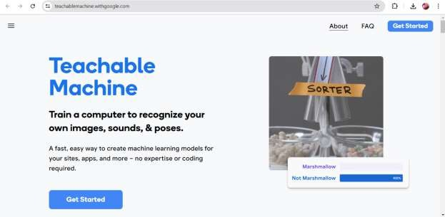

Click on get started.

1. After click on get started it appears like……..

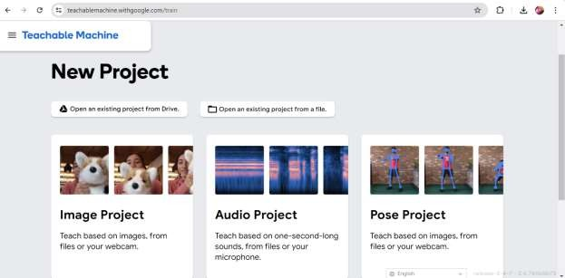

Here you can choose the project you like.Here I am going to select Image project

1. After selecting project we have to label the images using web cam or you can upload the images directly

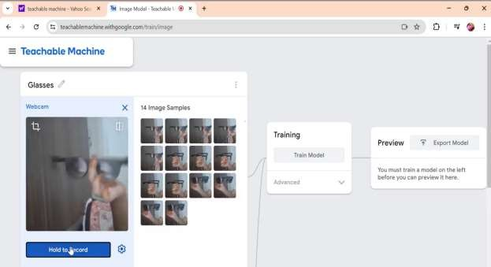

After labelling click on training then it will going to train the model.

1. After training go to export model in that we can use web cam to test the model the output like ..

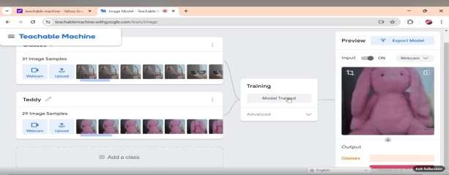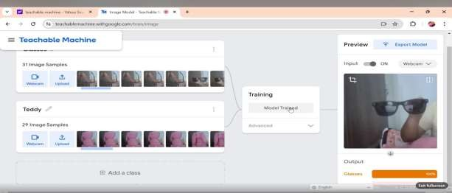

In above both images we observe that the images are identified as well as classified. like this we can use google teachable machine to classify the images

# Image Object Detection

Inorder to detect the object we can use the platform called Roboflow .in that we have a large number of pre-trained data sets.we can the data set in universe and train the model using yolo. YOLO is a powerful and widely used framework for image object detection due to its speed, efficiency, and capability to detect multiple objects in real-time.

For detecting object we need to create an account in roboflow

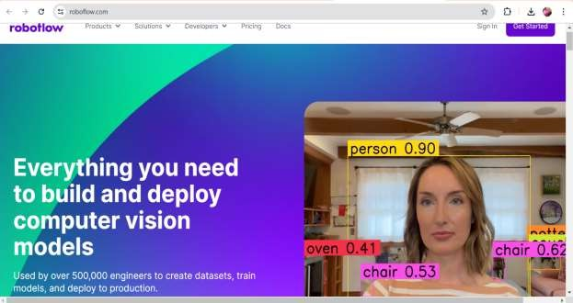

Click on sign in create a account with google.

**Create a project**

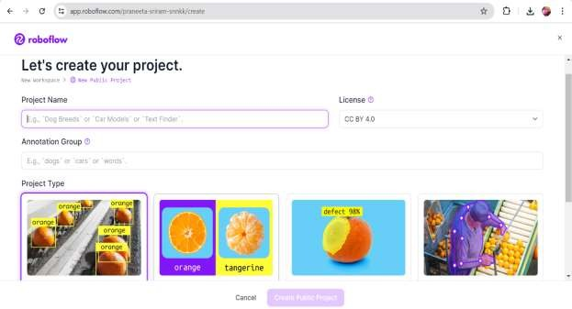

**Choose dataset**

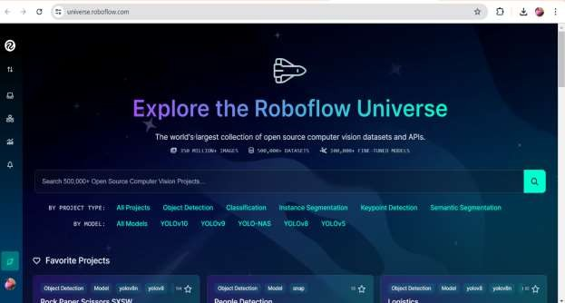

**Test the model**

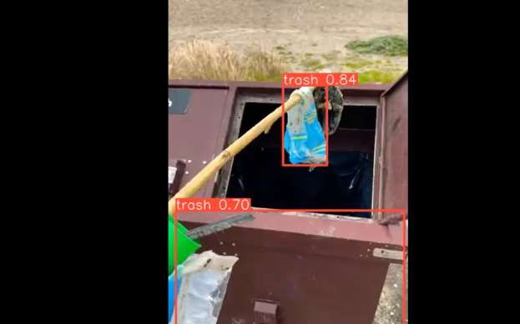

#### Object detection

Here it detect the objects car,small truck in the image.

# Yolo(You look only once)

YOLO, which stands for "**You Only Look Once,"** is a state-of-the-art real-time object detection system. YOLO have several versions like Yolov3, YOLOv5, YOLOv6, YOLOv8, YOLOv9.

YOLOv8 is the latest installment and it is better version compared YOLOv9 and all .YOLOv8 was developed by Ultralytics .

**Step by Step Process Involved for detecting object using YOLOv8**

1. you need to create an account in Roboflow
2. After creating a roboflow account you need to create a new project.

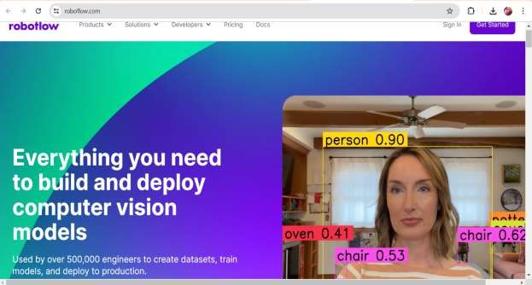

Click on create new project

1. After that,you can upload minimum 500 images or you can upload a youtube link and then we have to labell all the images that we need to detect.All 500 images we need ti label them

correctly

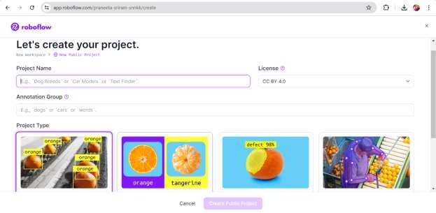

1. otherwise,we have an option called Universe Roboflow provides a number of universe datasets that are already labelled.

We can use that data sets also.

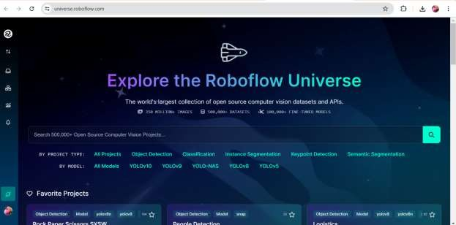

We have plenty of datasets in Universe.

1. Select a Dataset you want and download the dataset and you must use “YOLOv8” version then it can generate a code copy it. Then go to the AI model called YOLOv8 you can train the model on colab,Kaggle etc.. you need to choose colab.
2. After that,training in colab you must connect with runtime GPU.
3. Then train the model by running the cells.you can custom the model here you can change epoch rate also it means no.of iterations you need after that you can inference the model.
4. you must need to download the Best.pt file after the iterations completed it generates a file you must download it.
5. finally it give the path like runs/detect/predict your output is there you check and download it.

Otherwise, there is a option to connect with our drive you can connect with your drive and drag the out put to your drive.

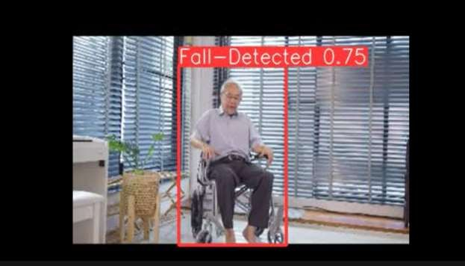



### Applications:

**Autonomous Driving**: YOLO models, including advanced versions like YOLOv8, can be used for real-time detection of pedestrians, vehicles, traffic signs, and other objects on the road, crucial for the perception module of autonomous vehicles.

**Medical Imaging**: Detecting and analyzing anomalies or specific organs in medical images for diagnosis and treatment planning.

**Surveillance and Security**: Monitoring environments in real-time to detect and track

people, objects, and suspicious activities. YOLOv8's efficiency in processing frames quickly could enhance surveillance systems.

1. Medical Image Analysis and Labelling

By using Robo flow platform we can Analyse Medical Images also. Roboflow is a platform that helps streamline the process of labeling and preparing data for training computer vision models, including for medical image analysis.

### Using Roboflow for Labeling Medical Images

1. **Data Upload:** Start by uploading your medical images to Roboflow. These images could be scans such as X-rays, MRI scans, CT scans, or histopathology images.
2. **Annotation:** Roboflow supports various annotation formats, such as bounding boxes for

object detection, semantic segmentation masks, or keypoint annotations. Choose the appropriate annotation type based on your analysis needs. For medical images, bounding boxes are often

used to highlight regions of interest (e.g., tumors, organs, anomalies).

1. **Labeling Interface:** Use Roboflow’s labeling interface to manually annotate objects in the medical images. You can draw bounding boxes around lesions, organs, or other structures of

interest. Ensure precise labeling to train accurate models.

1. **Automated Annotation:** Roboflow also offers tools for semi-automated or automated annotation, depending on the complexity and requirements of your dataset. This can speed up the annotation process, especially for large datasets.
2. **Quality Control:** Verify and review annotations to ensure accuracy and consistency across the dataset. Roboflow provides tools for reviewing annotations and correcting any errors.
3. **Export:** Once annotated, export your dataset in the desired format (e.g., COCO JSON, Pascal VOC XML, YOLO TXT) compatible with your chosen machine learning framework or tool.

Use same steps above in the YOLO .

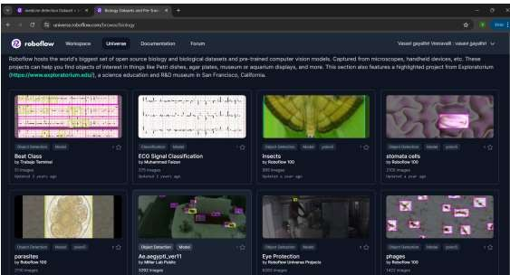

Choose the data set from here.

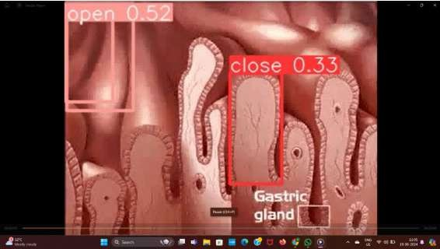

Here is a one of the small example what I have done is detecting weather the stomach cells are opened or closed.

In this I choose the Stomach cells dataset from universe and then train the model after that I choose a inference video from youtube and download it and uploaded to my project and then I got a result like above picture.

## Benefits of Using Roboflow

* + **Efficiency:** Streamline annotation workflows with intuitive tools and automated features.
  + **Accuracy:** Ensure precise labeling and annotation quality control for reliable model training.
  + **Compatibility:** Export annotated datasets in various formats compatible with popular machine learning frameworks.
  + **Scalability:** Manage large volumes of medical image data efficiently, facilitating research and clinical applications.

# Human Pose Estimation

For Estimating the Human poses we can use the platform called “Google Teachable Machine”.

Google Teachable Machine is a web-based tool developed by Google that allows users to easily train machine learning models without requiring extensive programming knowledge.

## Key Features of Google Teachable Machine

1. **Simple Interface:** Teachable Machine provides a user-friendly interface that doesn't

require coding skills. Users can get started quickly by uploading their own images, sounds, or poses for training.

1. **Training Models**: You can create three types of machine learning models:
   * **Image Classifier:** Classify images into custom categories. For example, differentiate between different types of fruits or animals.
   * **Pose Classifier:** Recognize poses captured from a webcam. This can be used for gesture recognition or exercise form analysis.
   * **Sound Classifier:** Identify and categorize sounds. For instance, distinguish between different musical instruments or environmental noises.

## Training Process:

* + **Data Collection:** Gather examples of each class you want the model to recognize. For example, collect multiple images of different types of flowers if training an image

classifier.

* + **Training:** Teachable Machine uses transfer learning to train the model based on the collected examples. Transfer learning leverages pre-trained models to speed up the

training process.

* + **Testing and Refinement:** After training, you can test the model’s performance in real-time using webcam input or by uploading new data. Refine the model by adding more examples or adjusting parameters if needed.



In this we have to choose pose project then upload the images from web cam or directly from the device

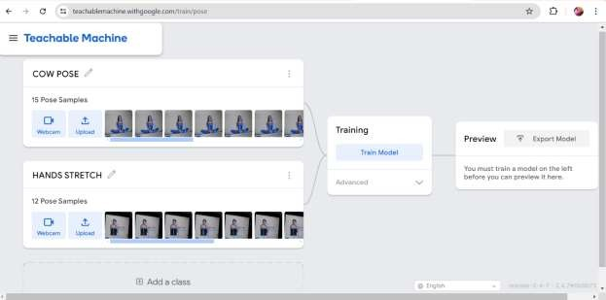

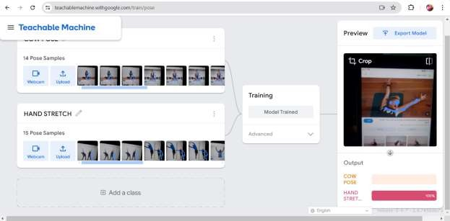

Here is the out put on pose estimation .

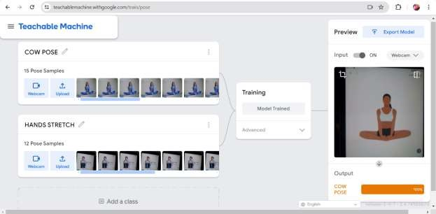

I use the web cam to label the images and train the model after I got the output like that.

## Applications of Google Teachable Machine

* + **Education:** Introduce students to machine learning concepts in a hands-on and interactive manner.
  + **Art and Creativity:** Enable artists to create interactive installations or digital artworks that respond to gestures or sounds.
  + **Prototyping:** Quickly prototype machine learning applications without extensive development resources.
  + **Personal Projects:** Hobbyists and enthusiasts can explore machine learning and develop custom models for personal projects or experiments.

# Mediapipe Studio

MediaPipe Studio is a tool developed by Google's MediaPipe team that simplifies the creation of real-time multimedia applications. It provides a graphical interface for building and customizing pipelines for media processing tasks such as image and video processing, object detection and

tracking, pose estimation, and more.

Pre-built Components: It includes a library of pre-built components for common media processing tasks, such as:

* + Image and video input/output handling
  + Face detection and recognition
  + Pose estimation
  + Hand tracking
  + Object detection and tracking

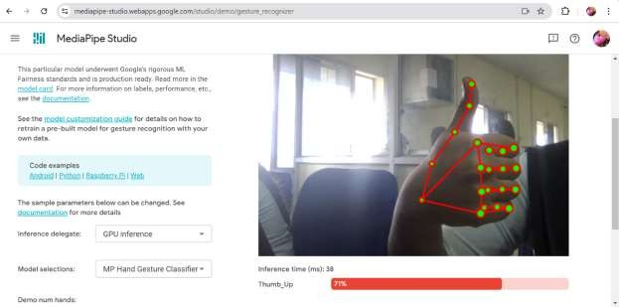

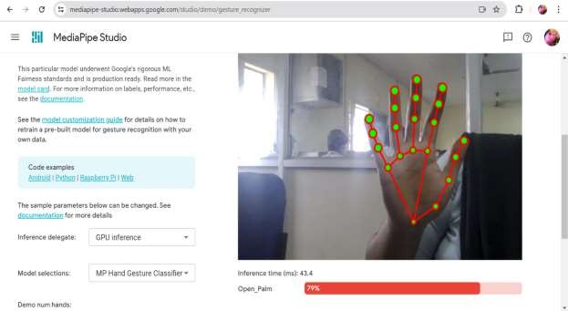

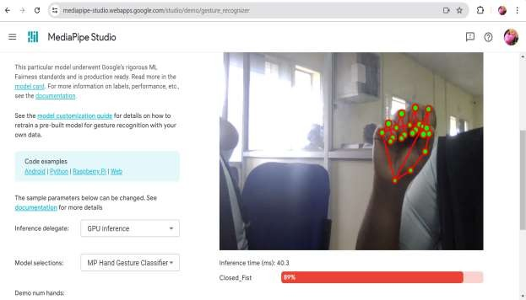

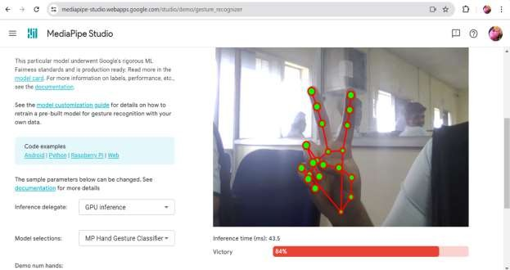

Here is what I done with MediaPipe Studio recognizing hand weather it is opened ,closed, thumbs-up, Victory etc……

# OpenCV Basics

OpenCV (Open Source Computer Vision Library) is a powerful open-source computer vision and machine learning software library. It provides a wide range of functionalities that are

essential for tasks involving image and video processing, including both simple and advanced operations. Here are some fundamental concepts and functionalities of OpenCV:

## Fundamental Concepts:

**Image Representation:** OpenCV represents images as multidimensional arrays (matrices or tensors), where each element represents the intensity or color value of a pixel. It supports various color spaces like RGB, HSV, grayscale, etc.

**Image i/o:** OpenCV can read and write images in various formats, including JPEG, PNG, BMP, TIFF, etc. It also supports video file formats for processing video streams.

* + **Image Processing Operations:** OpenCV provides a plethora of operations for image manipulation and processing, such as:
  + **Filtering and Convolution:** Applying filters like Gaussian blur, median blur, and custom kernels using convolution.
  + **Geometric Transformations:** Resizing, rotating, translating (shifting), and affine transformations.
  + **Thresholding and Binarization:** Converting grayscale images to binary images based on intensity thresholds.

**Morphological Operations:** Erosion, dilation, opening, closing to process binary images.

**Histogram Operations:** Calculation, equalization, and matching of image histograms.

**Feature Detection and Description:** OpenCV includes algorithms for:

**Feature Detection:** Identifying key points in images, such as corners (Harris corner detector, Shi-Tomasi corner detector).

**Feature Description:** Describing local image patches around keypoints (e.g., SIFT, SURF, ORB).

## Object Detection and Recognition:

**Haar Cascade Classifiers:** Used for detecting objects like faces.

**Deep Learning-based Object Detection:** Integration with frameworks like TensorFlow and PyTorch for more advanced object detection models (e.g., YOLO, SSD).

## Camera Calibration and 3D Reconstruction:

**Camera Calibration:** Estimating camera parameters such as intrinsic and extrinsic matrices. **Structure from Motion (SfM):** Building 3D models from multiple images or video frames.

**Machine Learning and Deep Learning Integration:** OpenCV has bindings for popular machine learning frameworks (like TensorFlow, PyTorch) and includes its own machine learning module (cv::ml) for tasks like classification, regression, clustering, etc.

## Functionalities:

**Image and Video I/O:** Loading, saving, and streaming of images and videos.

**Image Processing:** Filtering, transformations, color space conversions, and enhancement techniques.

**Feature Detection and Description:** Key point detection, feature matching, and local invariant descriptors.

**Object Detection and Tracking:** Pre-trained models (like Haar cascades) and deep learning-based object detectors (e.g., using SSD, YOLO).

**Camera Calibration and 3D Reconstruction:** Calibrating cameras and reconstructing 3D scenes from multiple images.

**Machine Learning:** Integration with machine learning frameworks for training and inference, and standalone algorithms in the cv::ml module.

**GUI and Visualization:** Tools for displaying images, drawing shapes, and annotations. **Performance Optimization:** Utilizes hardware acceleration (like SSE, AVX) and parallel processing (OpenMP) for efficient computation.

# Chatbot Development

Chatbot means creating an interaction between human and AI. A human can directly interact with AI with natural language . Here I developed a “Telegram Bot” using chat gpt, api keys,and

telegram etc…….

## Steps to create a “Telegram Bot”

1. you need to download Telegram in your mobile or laptop or desktop.
2. create an account in telegram.
3. search with @BotFather

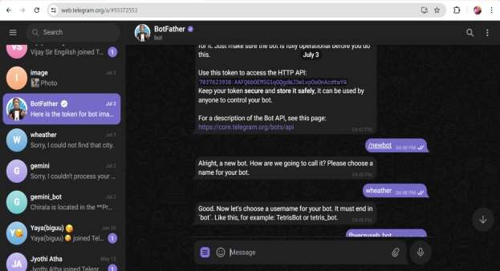

Send a /start command

1. send a /newbot command then it will response you
2. it asks choose a name for your bot you need to give the name for your bot
3. again it asks a username for your bot you need o give a user name to your bot.

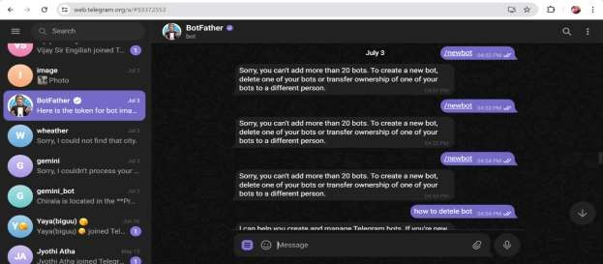

1. It generate your telegram bot token you need to copy it In that it provide your bot link also.
2. But it not worked because it doesn’t have any backend

For that we use a python code to it you can run the code in any python platform here iam using google colab take a new notebook install the packages required and run the main code int that

code we need to change the telegram bot token that was generated by Bot Father and also change the “Api key” with your system generated key.

And then run the code go to you bot ask something it will interact with you . It only can interact with us only when code is running .

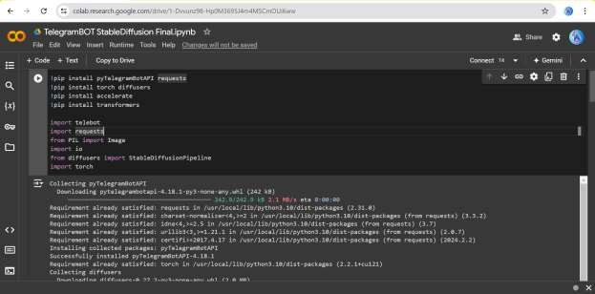

Here are the packages required to install

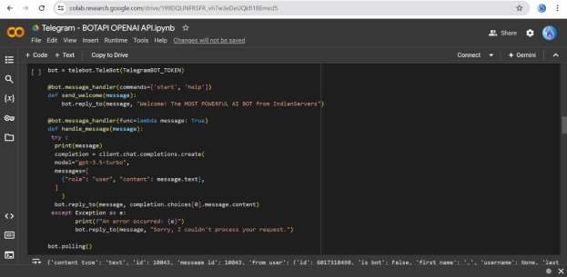

It is the code

Now I will share how it works

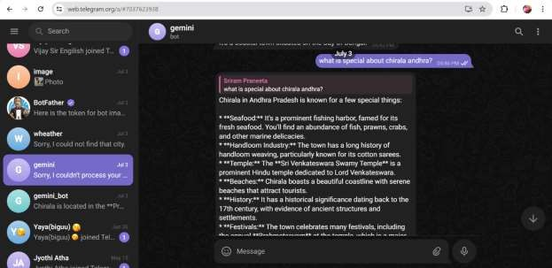

It interacts in an attractive way it will answer to everything we ask. Finally it is my “**Telegram Bot**”.

# Google Dialogflow

Dialogflow is a powerful development suite offered by Google for building conversational

interfaces such as chatbots and voice applications. It enables developers to create natural and rich conversational experiences that can be integrated with various platforms and devices.

Here’s an overview of Google Dialogflow and its key features:

## Key Features of Google Dialogflow:

1. **Natural Language Understanding (NLU):**
   * **Intent Detection:** Dialogflow allows you to define user intents (what users want to do) and train the system to recognize these intents from user input.
   * **Entity Recognition:** Identify and extract specific parameters or entities from user messages, such as dates, locations, or product names.

## Conversational Design Tools:

* + **Dialog Design:** Use a graphical interface to design conversational flows, including defining responses for different intents and managing context across conversations.
  + **Rich Responses:** Create responses that include text, images, buttons, cards, and quick replies to provide a more engaging user experience.

## Multi-platform Support:

* + **Integration:** Easily integrate Dialogflow with various platforms including websites, mobile apps (iOS and Android), messaging platforms (such as Facebook Messenger, Slack), and voice assistants (like Google Assistant and Amazon Alexa).
  + **Multi-language Support:** Dialogflow supports multiple languages, allowing developers to create multilingual chatbots that can serve users globally.

## Machine Learning Capabilities:

**Automatic Training:** Dialogflow uses machine learning to continuously improve its understanding of user inputs over time, reducing the need for manual updates.

**Pre-built Agents:** Utilize pre-built agents and templates for common use cases (e.g., booking appointments, customer support), accelerating development and deployment.

## Analytics and Insights:

**Analytics Dashboard:** Gain insights into user interactions, including usage patterns, frequently asked questions, and user satisfaction metrics.

**Integration with Google Cloud:** Leverage Google Cloud services for advanced analytics, scaling, and security capabilities.

## Enterprise-grade Security and Compliance:

**Data Privacy:** Dialogflow adheres to Google’s robust security practices, ensuring data protection and compliance with industry standards and regulations.

**HIPAA Compliance:** Supports healthcare applications requiring HIPAA compliance for handling sensitive patient information

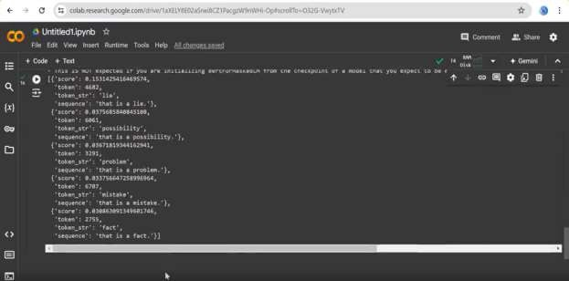

Here I developed a language translator it can translate English language to Spanish, French, hindi, Telugu etc…

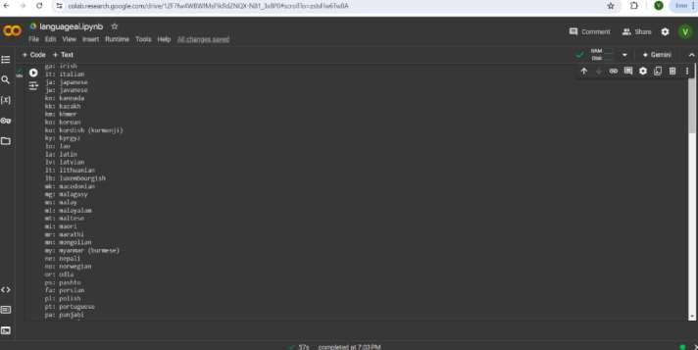

These are some of supported languages and their shortcuts..

# Generative AI

Generative AI means Techniques and models used to generate new content, such as music, text, and images.It can generate anything such as:

**Music Generation:** Creating music using AI models.

**Text Generation:** Producing coherent and contextually relevant text using AI.

**Image Generation Models:** Generating new images using AI techniques.

## Music generation:

In order to generate music using AI models we can use the platform called: <https://huggingface.co/spaces/facebook/MusicGen>

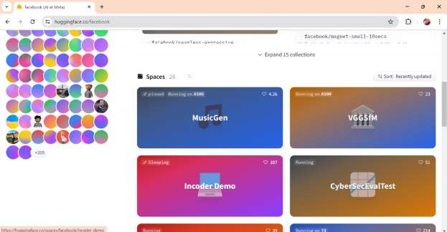

Select the music Gen

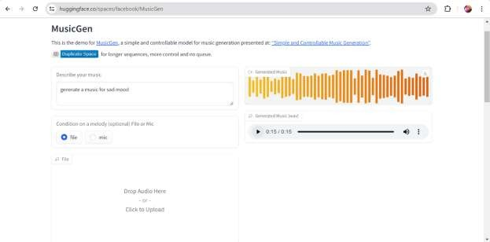

Describe your own music here.

## Text Generation:

Inorder to generate text we widely use Chat Gpt it one of the modt power ful AI. I liked it very much I face a good experience also. It provide solution for every thing.

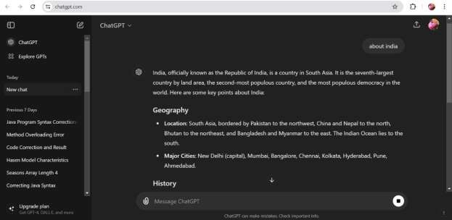

## Image Generation:

Inorder to generate images we can use the platform called: DALL-E It is also a one of best AI model.

It can generate images that doesn’t existed in real world.

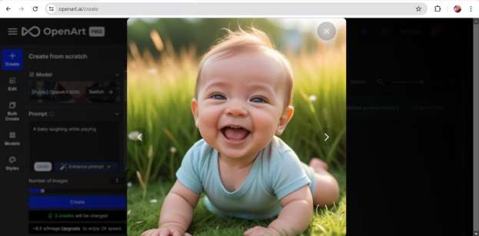

Here I can generate a image using DALL-E by giving prompt to it .

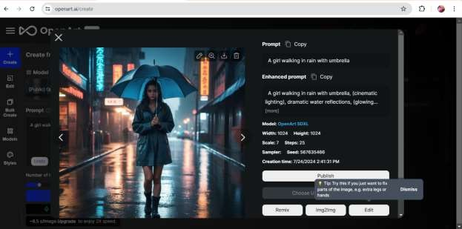

* + Sora open AI is also a AI mode that generate videos according to our prompt

# AI Models

Various models used for different AI applications.

* + - Summarization: Creating concise summaries of larger texts.
    - Fill-mask Models: Predicting masked words within a sentence.
    - Transformers: Models that use self-attention mechanisms to process sequential data.

## summarization:

For summarization we use the platform “Hugging face”.

In that go to models and then go to NLP and then choose summarization then it shows no.of data sets choose one dataset and go to use this model under this choose transformer and it gives a code copy it and run in google colab.

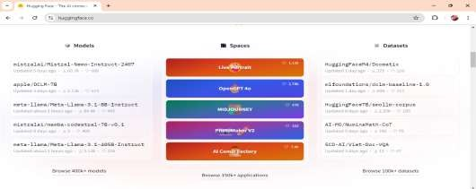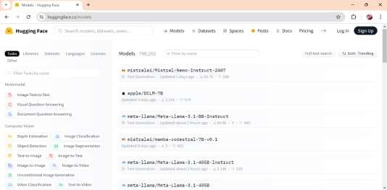

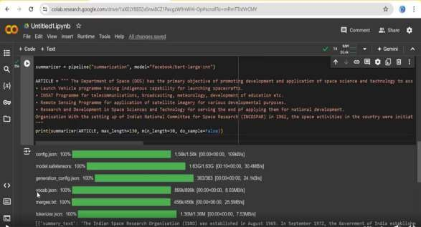

## Fill-mask Models:

Output for summarization

For Fill-mask Models we use the platform “Hugging face”.

In that go to models and then go to NLP and then choose Fill-mask then it shows no.of data sets choose one dataset and go to use this model under this choose transformer and it gives a code copy it and run in google colab.

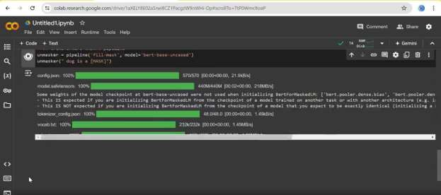

Output for Fill-mask model.

#### Transformers:

For transformers Models we use the platform “**Hugging face**”.

In that go to models and then go to NLP and then choose Transformers or search with

transformers then it shows no.of data sets choose one dataset and go to use this model under this choose transformer and it gives a code copy it and run in google colab.

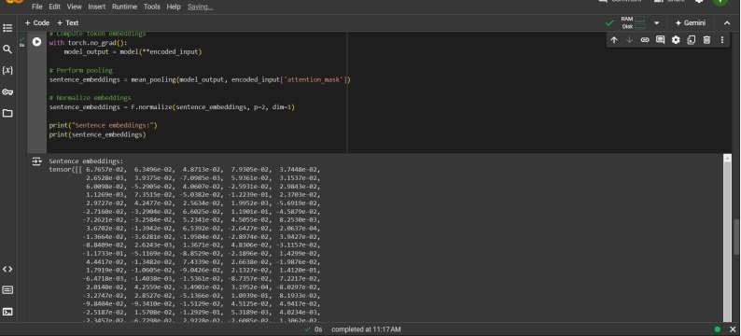

# Visual Question & Answering

It is a model that can answer the question according to images.

**Visual Question Answering (VQA)** is a challenging task in artificial intelligence that

involves understanding both images and natural language questions about those images. The goal is to develop models that can correctly answer questions about visual content based on the understanding of both visual and textual information.

## Input:

* **Image:** An image containing objects, scenes, or actions that is used as the visual context.
* **Question:** A natural language question (e.g., "What is the color of the car?" or "How many people are in the park?") that asks about the content of the image.

## Output:

* + **Answer:** The output of the VQA system is a textual answer (e.g., "Red" or "Three people") that correctly responds to the question based on the visual content of the

image.

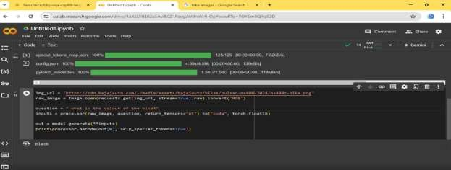

Here I upload a flower image url and ask how many flowers in the image it works and answer as 1 it is correct

# Document Question & Answering

Models that answer questions based on document content typically fall under the category of document question answering (QA) systems. These systems are designed to understand and extract information from textual documents to provide accurate answers to natural language questions.

Here are some common approaches and models used for document QA:

## BERT (Bidirectional Encoder Representations from Transformers):

* + BERT-based models have been widely used for document QA tasks. They are pre-

trained on large corpora of text and fine-tuned on QA datasets to understand context and relationships within documents.

## RoBERTa (A Robustly Optimized BERT Pretraining Approach):

* + RoBERTa is another variant of BERT that has shown improved performance on

various NLP tasks, including document QA. It leverages larger training datasets and modified training objectives to enhance language representation.

## XLNet (eXtreme Learning Machine Network):

* + XLNet is a transformer-based model that overcomes the limitations of sequential factorization in BERT by considering all possible permutations of words in a

sequence. This allows it to capture bidirectional context more effectively and perform well on document QA tasks.

## ALBERT (A Lite BERT):

* + ALBERT is a "lite" version of BERT that achieves competitive performance with fewer parameters. It is designed to scale well across different tasks, including

document QA, by improving parameter efficiency and training techniques.

## Transformer-based Models with Fine-tuning:

* + Apart from BERT, RoBERTa, XLNet, and ALBERT, various other transformer- based models have been adapted and fine-tuned for document QA tasks.These

models include DistilBERT, ELECTRA, and T5 (Text-to-Text TransferTransformer).

## Domain-Specific QA Systems:

* + In addition to general-purpose models, there are domain-specific QA systems

tailored for specific types of documents, such as legal documents, medical records, scientific papers, etc. These systems often incorporate domain-specific knowledge bases or ontologies to enhance accuracy.

## Pipeline Models for Document QA:

* + Some platforms and libraries offer pre-built pipelines for document QA tasks, which integrate preprocessing, document understanding, and QA model inference into a

streamlined workflow. Examples include Hugging Face Transformers library with its

DocumentQuestionAnsweringPipeline.

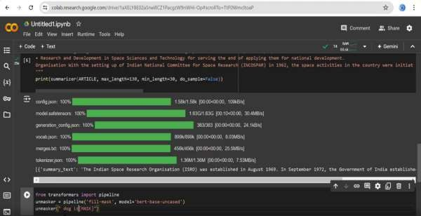

By providing the document to our code we can able get answers to any questions.

1. Table Question & Answering

Models that answer questions using tabular data typically fall under the category of structured data analysis or structured data question answering systems. These models are designed to

process and understand information presented in tabular form, such as spreadsheets or databases, and respond to natural language queries about that data.

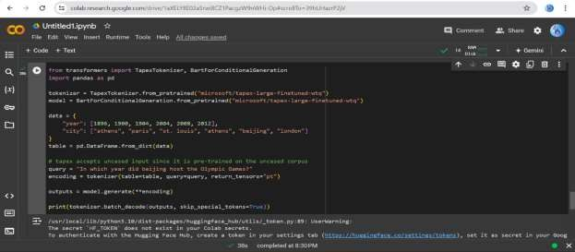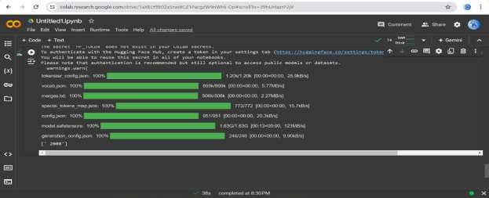

In this we need to mention data in the form table means in the form of rows and columns After that you can ask questions according to data that you provide.

# Large Language Models (LLMs)

Advanced language models that understand and generate human-like text.

* + Claude: A large language model known for its performance in text generation.
  + GPT: Generative Pre-trained Transformer, a state-of-the-art language model.
  + Gemini: An AI model focused on text and language understanding.
  + LLaMA3: A large language model by Meta AI.
  + Open LLMs: Various open-source large language models.

## Claude

Claude is a large language model and have great performance in in text generation. It is like chat gpt claude also provide answers to every thing

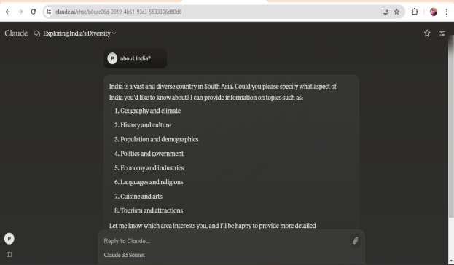

### GPT (Generative Pre-trained Transformer):

* + GPT refers to the series of language models developed by OpenAI, starting from GPT-1 to the latest version like GPT-3. These models are based on the Transformer architecture and are pre-trained on vast amounts of text data to perform a wide range of natural

language processing tasks, including text generation, translation, summarization, and more

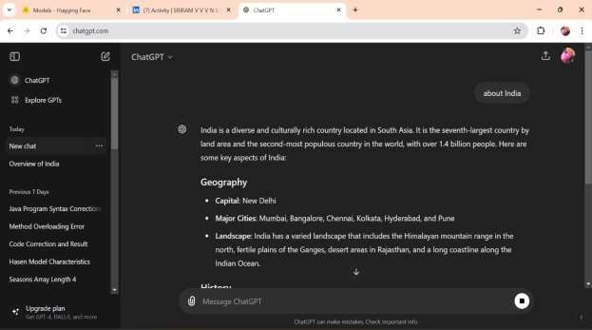

## Gemini:

* + Gemini is an AI model focused on text and language understanding. It's known for its capabilities in semantic understanding, contextual reasoning, and generating coherent

responses in conversation-like settings. Details about Gemini's specific architecture and training methods would depend on the organization or research group developing it.

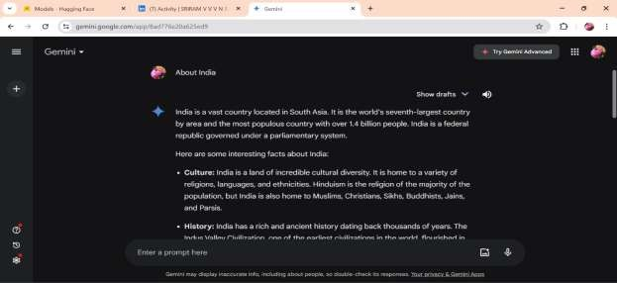

## LLaMA3:

* + LLaMA3 is a large language model developed by Meta AI (formerly Facebook AI). It belongs to the LLaMA (Large Language Model Meta AI) series, which are designed to excel in various natural language understanding and generation tasks. LLaMA3 likely

incorporates advancements in Transformer architecture and training techniques to achieve high performance

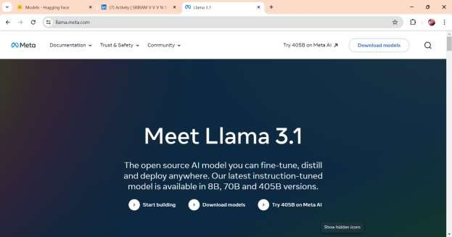

## Open LLMs:

* + Open LLMs refers to various open-source large language models available in the AI community. These models are developed and maintained by different research

organizations, universities, and AI enthusiasts. They provide accessible resources for researchers, developers, and enthusiasts to explore and build upon state-of-the-art

language models.

# Other Topics

## Using Vision API: Implementing Google's Vision API for image analysis:

* + Google's Vision API allows developers to integrate powerful image analysis capabilities into applications. It supports tasks like label detection, face detection, landmark

detection, optical character recognition (OCR), and more. Developers can use the Vision API to extract valuable information from images, making it useful for tasks ranging from content moderation to document scanning and augmented reality applications.

## Small Language Models (SLMs) - BERT, GPT: Efficient language models for various NLP tasks:

* + Small Language Models (SLMs) refer to compact versions of larger language models like BERT (Bidirectional Encoder Representations from Transformers) and GPT (Generative Pre-trained Transformer). These models are optimized for efficiency while maintaining competitive performance in natural language processing tasks such as text classification, named entity recognition, and sentiment analysis. SLMs are particularly useful for

deployment on resource-constrained devices or applications where real-time inference is crucial.

## Ultralytics Hub: A platform for deploying and managing AI models:

* + Ultralytics Hub is a platform designed for deploying and managing AI models. It provides capabilities for model hosting, versioning, monitoring, and scalability

management. Such platforms simplify the deployment process, facilitate collaboration among data scientists and engineers, and ensure efficient model lifecycle management from development to production.

## TensorFlow Lite Models: Lightweight models for mobile and embedded devices:

* + TensorFlow Lite is a framework for deploying machine learning models on mobile and embedded devices. TensorFlow Lite models are optimized for performance and size, making them suitable for applications where computational resources are limited, such as

smartphones, IoT devices, and edge computing scenarios. These models enable tasks like image classification, object detection, and natural language understanding directly on

device hardware, enhancing privacy and reducing latency**.**

## Sentiment Analysis: Determining the sentiment expressed in a piece of text:

* + Sentiment analysis involves using natural language processing techniques to determine

the sentiment (positive, negative, neutral) expressed in a piece of text. It's widely used in applications like social media monitoring, customer feedback analysis, and brand

reputation management. Machine learning models, including neural networks and

traditional statistical methods, are employed to classify the sentiment of text based on contextual clues and linguistic patterns**.**

## Deepfakes: Synthetic media where a person in an existing image or video is replaced with someone else's likeness:

* + Deepfakes are generated using deep learning techniques, particularly generative adversarial networks (GANs), to replace a person's face in an image or video with

another person's likeness. While they have potential applications in entertainment and

digital content creation, deepfakes also raise concerns regarding misinformation, privacy infringement, and ethical implications. Efforts are ongoing to develop detection methods and policies to mitigate the negative impact of malicious uses of deepfake technology.

* + Sentiment analysis involves using natural language processing techniques to determine

the sentiment (positive, negative, neutral) expressed in a piece of text. It's widely used in applications like social media monitoring, customer feedback analysis, and brand

reputation management. Machine learning models, including neural networks and

traditional statistical methods, are employed to classify the sentiment of text based on contextual clues and linguistic patterns.

## Deepfakes: Synthetic media where a person in an existing image or video is replaced with someone else's likeness:

* Deepfakes are generated using deep learning techniques, particularly generative adversarial networks (GANs), to replace a person's face in an image or video with

another person's likeness. While they have potential applications in entertainment and digital content creation, deepfakes also raise concerns regarding misinformation,

privacy infringement, and ethical implications. Efforts are ongoing to develop

detection methods and policies to mitigate the negative impact of malicious uses of deepfake technology.

***

# Conclusion

As I am Artificial Intelligence & Machine Learning student , I have some knowledge according to the Artificial intelligence and machine learning.

This internship helps me to grab more knowledge on the AI and ML. Also helps me to

understand more no.of techniques to used in these fields by having a practical practice on them with the mentorship of **Mr. Sai Sathish.**

In this internship the assignments given by the Mentor helps me to explore more in these fields to complete these tasks,this creates more intrest to learn the subject .

This type of practical internship helps the students like us to have some practical experience In this internship I came through a new topic named “ **CYBER SECURITY** ”,

I don’t have any knowledge about cyber security, the sessions about cyber security helps me to know about ‘what is cyber security ?’, ‘why we use cyber security?’, ‘how we use cyber

security?’ and more…

Now a days cyber crimes are more often to everyone as this world is floating in the world of internet. This helps the hacker to do more crimes.

By this knowledge I can protect myself and my family Not to become a victmin of Cyber Crimes

# References

**References:**

1. **chat Gpt main resourse I used in this internship.**
2. **google – mediapipe studio 3.youtube.**
3. **many websites for internship.**
4. **Hugging face.**
5. **tensorflow**

**Acknowledgments:**

I wish to express my thanks to various personalities who are responsible for the completion of

the internship. First of all, I, **SHAIK NAJEER SULTHAN,** the student of **St. Ann’s College of Engineering & Technology, chirala**

Our college Computer Sience and Engineering (CSE) HOD:

I would also be thankful to our Head of Department, **Dr. P. Harini** of St. Ann’s College of Engineering & Technology, for providing these intellectual internship & programs for us.

Internship Organization:

Artificial Intelligence Medical and Engineering Researchers Society (AIMER) CEO:

I would like to thank **Mr. Sai Satish sir** for giving us opportunity to do the **Artificial intelligence** internship within the Organization

I would like to extend my deep appreciation to all officials of the college, without their support and coordination, we would not have been able to complete this project.

SHAIK NAJEER SULTHAN